## horizontal line



Functionality Specification Document

----------------------------------------------------------------------------------------------------------------------------

**Document Version 1.0**

**Latest updated:- 30-Sep–2020**

**Author : Omkar S Mayekar**

**Company Lockers Pvt. Ltd.**

**Content**

**1 . About this Document………………………………........2**

**1.1 How this Document is organized ……………………………………………………….. 2**

**1.2 Contact Information..……………………………………………………………………. 3**

**2 . Introduction……………………………………………....4**

**2.1 Objectives…………………………………………………………………….………........ 4**

**2.2 Scope…….…………………………………………………………………….………........5**

**3 . Solution Overview………………………………………..6**

**3.1 User Interfaces …………………………………………………………………………. …6**

**4 . Open Items……………………………………………....14**

**5 . Github link……………………………………………....15**



1. **About this Document**

**This functional and integration (FIS) document will enable you to understand the proposed solution of Company Lockers Pvt. Ltd.**

**The content of the document will have a solution and its configuration details as it will be available for our client.**

**1.1 How this Document is organized**

**This document is organized into following chapters:**

**Chapter 2 - "Introduction" provides solution scope to be delivered to our Client.**

**Chapter 3 - "Solution Overview" provides information on Company Lockers Pvt. Ltd. ,**

**Components and Interfaces in system.**

**Chapter 4 - “Open Items” provide information about the software enhancement**

**still to be done.**

**Chapter 5- “Github link” provides the information where the project is located.**

**1.2 Contact Information**

**Company Lockers Pvt. Ltd. welcomes your comments and suggestions on the quality and usefulness of this document. For any questions, comments, or suggestions on the documentation, you can contact us at the following address:**

|  |
| --- |
| **For India Enquiry .**  **Omkar Mayekar**  **Company Lockers Pvt. Ltd. India**  **Tel: +91 (742) 081 5182**  **contact_us@CompanyLockersPvtLtd**  **India.** |



**2 . Introduction**

**This document describes the implementation of *Company Lockers Pvt. Ltd.* and how its users can interact with the application.**

***Company Lockers Pvt. Ltd.* offers an interactive solution for the user to perform various file management system operations.**

**2.1 Objectives**

**The objective of this document is to describe how the solution of *Company Lockers Pvt. Ltd.* will integrate with User.**

**This document also provides information on end to end workflow flow so that business users can understand the features and functionalities of the *Company Lockers Pvt. Ltd.* file management system.**

**The workflow mainly involves the following important aspects,**

**1. Display all the contents present in that particular directory.**

**2. Explore the other option**

**3. Exit**

**2.2 Scope**

**The scope of the solution will be limited to the functionality mentioned in this document.**

**This document covers the scope for following functionalities**



|  |  |
| --- | --- |
| **Phase 1 Solution** | **-----------------------------------------------------------------------------**  **1 - Add a new folder.**  **2 - Delete existing directory**  **3 - Search for an existing file/directory**  **4 - ﻿Sort the file/folders**  **===========================================**    **-----------------------------------------------------------------------------**  **1 - Add a new folder.**  **2 - Delete existing directory**  **2.1 Prompting option added**  **3 - Add a new file.**  **4 - Search for an existing file/directory**  **5 - ﻿Sort the file/folders**  **6 - Go to main menu** |

**=====================================================================**



**3 Solution Overview**

**This chapter provides information on the *Company Lockers Pvt. Ltd.* UI which will be used for the user to interact.**

**3.1 User Interfaces**

**The user interface application will be available in English language.**

**Platform requirement**

**The platform used for this project is the eclipse IDE.**

**Below is the welcome page of the application**

**=====================================================================**

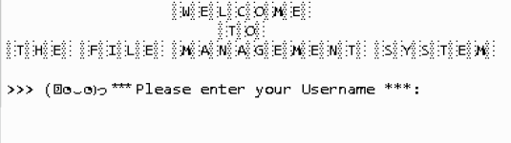

**=====================================================================**

**Step 1 - The application begins with the user entering his valid username.**

**In this case the username is : Omkar(It can be entered in any case)**

**Once the user is validated the application display the below options for the user to interact :**

1. **View the contents present in the directory**
2. **Explore other options**
3. **Exit**

**----------------------------------------------------------------------------------------------------------------------------**

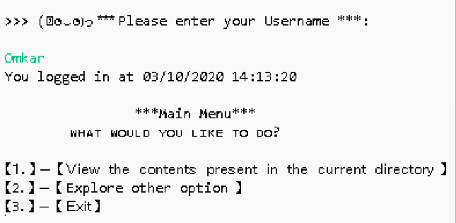

**=====================================================================**

**=====================================================================**

**Option 1 - As the user chooses option 1 the following page is displayed.**

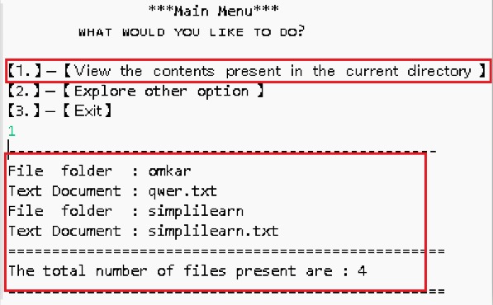

**=====================================================================**

**Option 2 - As the user chooses option 2 the following submenu are displayed.**

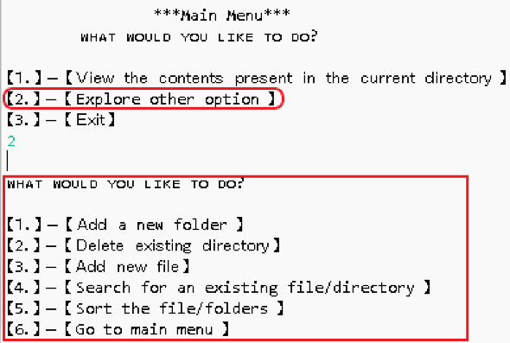

**=====================================================================**

1. **Add a new folder**

**A user can create a folder using this option . This application first checks if the folder name entered by the user is valid or not e.g if the user tries to add any name of folder followed by .txt extension then it would not accept the folder. The folder should not contain any file extension in this case it is “.txt”.**

**Also if the entered name of the folder exists then it doesn't add the folder since the folder already exists.**

**=====================================================================**

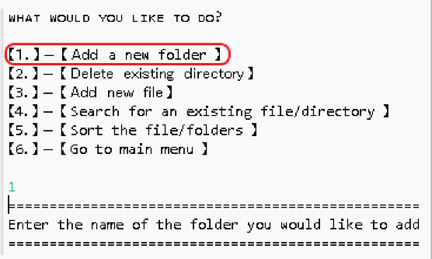

**=====================================================================**

1. **Delete existing directory/file.**

**A user can delete a file/folder using this option. The application checks if the folder the user is trying to delete already exists into the directory, if yes then it prompts whether the user is sure he wants to delete the folder. The folder is only deleted if appropriate confirmation is given.**

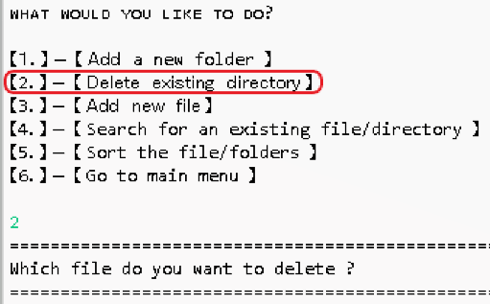

**=====================================================================**

1. **Add new file**

**A user can create a .txt file using this option . This application first checks if the file name entered by the user is valid or not e.g if the user tries to add any name of file without .txt extension then it would not accept the folder. The file must contain an extension . In this case it is “.txt”.**

**Also if the entered name of the file exists then it doesn't add the file since it is already present.**

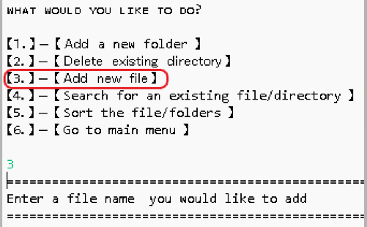

**=====================================================================**

1. **Search for an existing file/directory**

**A user can search for an existing file/folder in the directory if found it will specify that it is found and the index at which it was found and if not found stating that the file/folder is not available.**

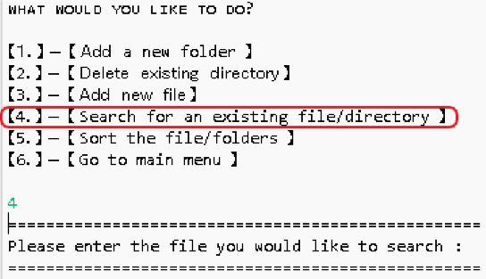

1. **Sort the file/folder**

**A user can sort the file/folder according to their choice i.e ascending or descending.**

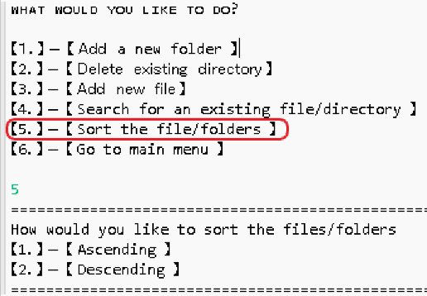

**=====================================================================**

1. **Go to the main menu.**

**This option enables the user to go back to the previous menu without exiting the application.**

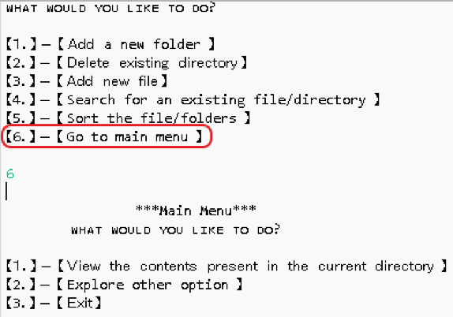

**==================================================================**

**Option 3 - As the user chooses option 3 the user exits from the application.**

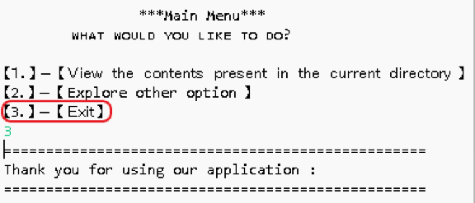



**4. Open Items**

**This section mentions the open issues for the project. These are the items out of scope for this document, and it will be revisited at a late date once additional information / requirements clarity has been provided. If, agreed and approved between Company Lockers Pvt. Ltd. and client, then the new specification / change requests for these items will be drafted, along with its impact and cost estimations.**



|  |  |  |  |
| --- | --- | --- | --- |
| **1** | **The creation time and size of the created file/ folder.** | **Company Lockers Pvt. Ltd.** | **Open** |

|  |  |  |  |
| --- | --- | --- | --- |
| **2** | **Sorting on the basis of size and file/ folder creation time.** | **Company Lockers Pvt. Ltd.** | **Open** |

|  |  |  |  |
| --- | --- | --- | --- |
| **3** | **Logout after 5 minutes of user inactivity.** | **Company Lockers Pvt. Ltd.** | **Open** |

|  |  |  |  |
| --- | --- | --- | --- |
| **4** | **Adding or Deleting multiple files and folder at a time..** | **Company Lockers Pvt. Ltd.** | **Open** |



**5. Github link**

**This section lists where the source code is located and from where the user can download and use it.**

[**https://github.com/mayekaromkar15/phase1_project**](https://github.com/mayekaromkar15/phase1_project)